CHANDIGARH UNIVERSITY

QSAR Fish Toxicity

Submitted in partial fulfillment of the requirements for the award of degree of

BACHELOR OF ENGINEERING

IN

COMPUTER SCIENCE & ENGINEERING


Submitted to:
Assistant Professor Richa Arora
Submitted By:
Riya Srivastava
UID: 17BCS1711 CI-2 (A)
Shubham Gaur
UID: 17BCS1920 CI-2 (A)
Muskan Abrol
UID: 17BCS1662 CI-2 (A)
Ayush Kumar
UID: 17BCS1686 CI-2 (A)

DEPARTMENT OF COMPUTER SCIENCE & ENGINEERING

Chandigarh University, Gharuan

April 2020

CHANDIGARH UNIVERSITY

CERTIFICATE

This is to certify that the work embodied in this Project Report entitled

“QSAR Fish Toxicity ” being submitted by “ Riya Srivastava

17BCS1711, Shubham Gaur 17BCS1920, Muskan Abrol 17BCS1662 and Ayush Kumar 17BCS1686” , 6th Semester for partial fulfillment of the requirement for the degree of “ Bachelor of Engineering in Computer Science & Engineering ” discipline in “ Chandigarh University

” during the academic session Jan-Apr 2020 is a record of bonafide piece of work, carried out by student under my supervision and guidance in the “

Department of Computer Science & Engineering ”, Chandigarh

University.

APPROVED & GUIDED BY:

Assistant Professor Richa Arora

CHANDIGARH UNIVERSITY

DECLARATION

I, student of Bachelor of Engineering in Computer Science & Engineering, 6th Semester , session: Jan – Apr 2020, Chandigarh University, hereby declare that the work presented in this Project Report entitled “QSAR Fish Toxicity ” is the outcome of my own work, is bona fide and correct to the best of my knowledge and this work has been carried out taking care of Engineering Ethics. The work presented does not infringe any patented work and has not been submitted to any other university or anywhere else for the award of any degree or any professional diploma.

STUDENT DETAILS AND SIGNATURE:

Riya Srivatava
17BCS1711
CI-2 (A)

Shubham Gaur
17BCS1920
CI-2 (A)

Muskan Abrol
17BCS1662
CI-2 (A)

Ayush Kumar
17BCS1686
CI-2 (A)

APPROVED & GUIDED BY:

Assistant Professor Richa Arora
CHANDIGARH UNIVERSITY

ACKNOWLEDGEMENT

The success and final outcome of this project required a lot of guidance and assistance from many people and I am extremely privileged to have got this all along the completion of my project. All that I have done is only due to such supervision and assistance and I would not forget to thank them.

I would like to express my special thanks of gratitude to my mentor Prof. Richa Arora who gave me the golden opportunity to do this wonderful project on the topic “University Interactive Assistance”, which also helped me in doing a lot of research and I came to know about so many new things I am really thankful to them.

I am thankful to and fortunate enough to get constant encouragement, support and guidance from all Teaching staffs which helped me in successfully completing my project work. Secondly I would also like to thank my parents and friends who helped me a lot in finalizing this project within the
limited time frame.

 |  | CHANDIGARH UNIVERSITY
 |  | Table of Contents
 | Certificate ....................................................................................................................... |  |  | ii
 | Declaration .................................................................................................................... |  |  | iii
 | Acknowledgements ........................................................................................................ |  |  | iv
 | Table of Contents ............................................................................................................ |  |  | v
 | List of Figures............................................................................................................... |  |  | xiv
 | List of Tables .............................................................................................................. |  |  | xvii
 | List of Acronyms .......................................................................................................... |  |  | xix
 | Terminology used .......................................................................................................... |  |  | xx
 | Abstract...................................................................................................... |  | xxiv
Sr. No. |  | Topic | Page No.
1. |  | CHAPTER 1: INTRODUCTION | 9-11
2. |  | CHAPTER 2: CHAPTER 2: SYSTEM | 12-15
2. |  | REQUIREMENT SPECIFICATION | 12-15
3 |  | CHAPTER 3: ARCHITECTURE DIAGRAM
 |  | LIKE (DFD, UML DIAGRAM) | 16-17
 |  | CHAPTER 4: PROJECT METHODOLOGY | 18-22
4.
5. |  | CHAPTER 5: RESULTS AND DISCUSSION | 23-27
 |  | CHAPTER 6: CONCLUSION AND FUTURE
6. |  | SCOPE | 28-29
7. |  | REFERENCES | 30

CHANDIGARH UNIVERSITY

LIST OF FIGURES

SL No. | Title | Page No.
 | Figure: 3.1: QSAR Fish Toxicity | 16
1. |  | 16
 | Figure 3.2: General methodology for QSAR
2. | Fish Toxicity | 17
3. | Figure 4.1: System Architecture for QSAR | 18
3. | Fish Toxicity | .
 |  | 20
4. | Figure4.2: Use Case Diagram
 | Figure4.3 : DFD | 22
5.

CHANDIGARH UNIVERSITY

CHANDIGARH UNIVERSITY

ABSTRACT

This paper is about the QSAR Fish Toxicity as in today’s modern era it is very important to take care of the fish life because the waste of the modern factory is released only in theses water bodies due to which many of the fish lives lose their due to the increase in the toxic substances in these water bodies and if we take in account of the food chain then we can understand how many such lives are in danger including humans because at the end these fish life’s are all part of the human delicacy and it is important to safeguard the lives of the fish lives as we are only saving our lives because indirectly we are also somehow connected with these animals that is why it is very important to predict the casualties in these water bodies for that the given dataset is helpful as the attributes included in the given dataset are the chemical compounds which are mostly released in the water bodies from different modern factories and for that we are using Weka to forecast the concentration of the chemical compounds present in the water bodies which will not only safe the lives of the animals present in the water bodies but also will help in saving the other animals lives including the humans as well although there are certain research papers which have accurately made the predictions but we are trying to increase the prediction accuracy.

We can understand how many such lives are in danger including humans because at the end these fish life’s are all part of the human delicacy and it is important to safeguard the lives of the fish lives as we are only saving our lives because indirectly we are also somehow connected with these animals that is why it is very important to predict the casualties in these water bodies for that the given dataset is helpful as the attributes included in the given dataset are the chemical compounds which are mostly released in the water bodies from different modern factories and for that we are using Weka to forecast the concentration of the chemical compounds present in the water bodies which will not only safe the lives of the animals present in the water bodies but also will help in saving the other animals lives including the humans as well although there are certain research papers which have accurately made the predictions but we are trying to increase the prediction accuracy.
CHANDIGARH UNIVERSITY

CHAPTER 1: INTRODUCTION

The study on the QSAR Fish Toxicity is made to accurately predict the concentrate of the toxic elements present in the fish bodies as it is very important to predict the concentration accurately because if we take in picture about the food chain then we will understand how much it is necessary to consider this research because in the mother earth everything is interconnected with each other and if one of the element in this structure is disturbed then the whole building will be effected as earlier I mentioned about the food chain if we mention this then we can say that every small is animal is a part of the other big animals cuisine. For instance take in consideration of the given dataset that is QSAR Fish toxicity it includes all the small fishes and that large also.

If small fishes are infected with the toxic elements present in the water bodies then when they are engulfed by the large fishes the same toxic elements come to the large fish bodies and humans are also dependent on sea foods of few countries from there these toxic elements move to human bodies and infect the humans from various disease which may include severe life taking diseases as well^{[2]}.

To control the spread of the diseases it is mandatory to develop such a device/machine which is capable to accurately predicting the presence of the toxic elements in the water bodies and in all the fish lives. For that the given dataset is constructed for that the sample of fish was taken and was breaded in the water body where the toxic elements were present in the numerous amount and the results which we found were heart breaking as around 50% of the fishes present in the water body were found dead after sometime and other were on their way to death and now imagine what will happen if we take those fishes as a food which are infected or breaded in the environment which is full of toxic elements the same condition will prevail in the human society that the person died due to severe life taking diseases and these disease originated from us only i.e. we are the who are releasing the toxic substances in the water bodies which are engulfed by the fishes present in those water bodies. We are conducting this research in order to increase the accuracy for the given dataset as there are research papers which got the accuracies but we are trying to get the better accuracy than those present research papers.
CHANDIGARH UNIVERSITY

The dataset which we have taken is from the UCI Repository and we are using Weka as the software to conduct the research and get the accuracy as per our assumptions. For that firstly we are required to make the dataset on which the operations can be performed and then we can get the desired output until and unless the dataset is not ready for the operation then it will be very difficult for us to get the desired accuracy.

Here we are using different machine learning algorithms in order to find such an algorithm which can help in increasing the accuracy of the training dataset and after the testing is to be done on the same dataset then also the algorithm is capable of predicting the output accurately as it will help in saving the lives of the fishes in the water bodies as most of the fish died due to the presence of the chemical compounds in the water bodies and if want to save the lives of the fish then we have to find such an algorithm which can easily predict the condition of the fish and we can save the life of the fish easily.

The dataset which we have taken is from the UCI Repository and we are using Weka as the software to conduct the research and get the accuracy as per our assumptions. For that firstly we are required to make the dataset on which the operations can be performed and then we can get the desired output until and unless the dataset is not ready for the operation then it will be very difficult for us to get the desired accuracy.

Here we are using different machine learning algorithms in order to find such an algorithm which can help in increasing the accuracy of the training dataset and after the testing is to be done on the same dataset then also the algorithm is capable of predicting the output accurately as it will help in saving the lives of the fishes in the water bodies as most of the fish died due to the presence of the chemical compounds in the water bodies and if want to save the lives of the fish then we have to find such an algorithm which can easily predict the condition of the fish and we can save the life of the fish easily.

The dataset which we have taken is from the UCI Repository and we are using Weka as the software to conduct the research and get the accuracy as per our assumptions. For that firstly we are required to make the dataset on which the operations can be performed and then we can get the desired output until and unless the dataset is not ready for the operation then it will be very difficult for us to get the desired accuracy.
CHANDIGARH UNIVERSITY

If small fishes are infected with the toxic elements present in the water bodies then when they are engulfed by the large fishes the same toxic elements come to the large fish bodies and humans are also dependent on sea foods of few countries from there these toxic elements move to human bodies and infect the humans from various disease which may include severe life taking diseases as well^{[2]}.

To control the spread of the diseases it is mandatory to develop such a device/machine which is capable to accurately predicting the presence of the toxic elements in the water bodies and in all the fish lives. For that the given dataset is constructed for that the sample of fish was taken and was breaded in the water body where the toxic elements were present in the numerous amount and the results which we found were heart breaking as around 50% of the fishes present in the water body were found dead after sometime and other were on their way to death and now imagine what will happen if we take those fishes as a food which are infected or breaded in the environment which is full of toxic elements the same condition will prevail in the human society that the person died due to severe life taking diseases and these disease originated from us only i.e. we are the who are releasing the toxic substances in the water bodies which are engulfed by the fishes present in those water bodies. We are conducting this research in order to increase the accuracy for the given dataset as there are research papers which got the accuracies but we are trying to get the better accuracy than those present research papers.
CHANDIGARH UNIVERSITY

CHAPTER 2: SYSTEM REQUIREMENT

SPECIFICATION

2.1 : System Requirements

The ultimate goal of this project is to design a digit detector that is able to store and log information. This project could be used in many applications, ranging from checking the condition of digits to searching for digit position. The end result of this project could be used for these applications in future developments in this field.

From these surveys, I was able to establish that the majority of to using it on Desktop/Laptop. I found that in the age range of 12-18 almost all users would only use a messaging application on a mobile device while users in the age range of 19-30 would use both a mobile device as well as a Desktop/Laptop. This may be due to the older using owning a Desktop/Laptop for college/work, while the younger users rely solely on their mobile device for communication purposes. With this information, I was able to conclude that the majority of users would prefer a digit recognition system that would function on a mobile platform. I have structured my requirements based around this information.

2.2 : Functional requirements

Functional requirements they key functional requirements can be identified as the following: The digit recognition system must identify the digit given in the form of the scanned images. This requirement at its most basic level is the core functionality of the digit recognition system. The system must respond to the user when scanned images are given. This sets the images up for the user and allows them to use the system as they desire. As this is a fundamental requirement for the application to work, it is considered a high priority.

2.3 : Usability requirements

Usability requirements the main usability requirement is that the recognition system and application are user friendly. The recognition system, in its own nature is user friendly since it is a simple recognition system. Everyone knows how a recognition system works as it is simply like a conversation with their friends.
CHANDIGARH UNIVERSITY

Non-Functional Requirements

Performance/Response time requirement Response Times: The Recognition System should reply to the user in a timely manner to keep the conversation flowing without interruption. Users value their time greatly and if the response is not quick enough the user will move on to a different website/app. Google conducted an experiment in regard to load times. They wanted to increase the number of search results shown per page to give the user more information to choose from. They upped the number of search results per page to 30, increasing the load time of the page by 0.5 seconds. Google concluded that traffic dropped by 20% just from a wait time increase of 0.5 seconds. Users value their time greatly so it is important that the Recognition System responds quickly.

Availability requirement

Availability requirement Recognition System must be available to chat at any time. This is achieved with Azure Cloud platform services. All code for the Recognition System is uploaded to Azure.

Security requirement

Security requirement the code must be stored securely by Azure Services and also user’s information must be kept secure. Azure use HTTPS (Secure Socket Layer) for all of their communications. Azure, developed by Microsoft, who has decades of experience and has built some of the most used and powerful software in the world take security very seriously. Microsoft complies with international and industry-specific compliance standards to ensure the security of data.

Reliability requirement

Reliability requirement The Recognition System must be consistent with its responses. It must be have consistently in a user-acceptable manner when communicating with a user. The information relayed to the user must be consistent with the dialog topic.

Maintainability requirement

Maintainability requirement The Recognition System must be able to be updated with up to date FAQ’s and timetables/exam timetables.

Portability requirement

CHANDIGARH UNIVERSITY

Portability requirement the application should be able to run on any device connected to the internet. The Recognition System can be hosted on a variety of social media platforms as well as on personal websites. Once the Recognition System is hosted on azure it can then be accessed by other sites and platforms.

Reusability requirement

Reusability requirement The .csv files can be used for different Recognition System and can be interchangeable between different bots.

Feasibility Study:

As the name implies, a feasibility analysis is used to determine the viability of

an idea, such as ensuring a project is legally and technically feasible as well as

economically justifiable. Feasibility study includes an estimate of the level of

expertise required for a project and who can provide it, quantitative and

qualitative assessments of other essential resources, identification of critical

points, a general timetable, and a general cost estimate.

My Recognition System is legally and technically feasible as well as

economically justifiable. It will not violate the rules and regulations of the

organization. It is very fast in processing, cost effective and resource effective.

Organization can upload it on student information system as it is light weight.

NEED AND SIGNIFICANCE
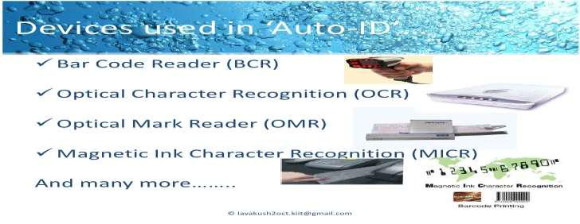

CHANDIGARH UNIVERSITY

The prime significance of using a Recognition System is its 365 days a year, 24/7 availability. Recognition System are the next step in information technology after the advent of websites and apps and are easier to maintain and upgrade if built correctly.

Software and Hardware Requirements:

Hardware

We need a computer having minimum:-
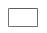

2 GB RAM.

- GB Hard-drive space. Operating System: Windows

Technology: Machine Learning

Software

We need following things to be installed on the computer:

- Python 3.

- Tensorflow

- NumPy library and its dependencies.

- SKLearn

As we are write coding in python language.

CHANDIGARH UNIVERSITY

CHAPTER 3: ARCHITECTURE DIAGRAM LIKE (DFD,

UML DIAGRAM)

DFD: Data Flow Diagram is the graphical description of the system's data and how the processes transform the data. Data Flow diagram depicts

information flow, the information flow and the transforms that are applied as data move from the input to output. It is the starting point of the design phase that functionally decomposes the requirement specifications down to the lowest level of details.

A DFD shows what kind of information will be input to and output from the system, how the data will advance through the system, and where the data will be stored. It does not show information about process timing or whether processes will operate in sequence or in parallel, unlike a traditional structured flowchart which focuses on control flow, or a UML activity workflow diagram, which presents both control and data flows as a unified model.
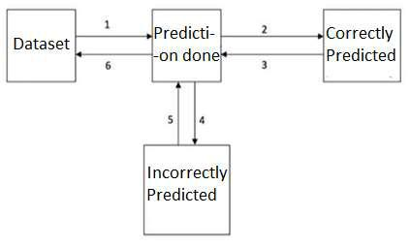

Figure: 3.1: Architecture of the QSAR Fish Toxicity

CHANDIGARH UNIVERSITY
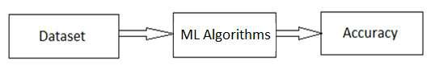

Figure 3.2: General methodology for QSAR Fish Toxicity

Specifications -

In this section we are discussing the problems which we faced while working on this dataset. The major problem was nothing but the dataset as the dataset which we got was completely uncleaned there were many problems in the dataset few of them are: - dataset on which we were working was in a single cell i.e. multiple attributes were in the single cell, the other problem was of the Null values and the blanks which we have to care of before working/proceeding further with this dataset. As before working on any of the dataset firstly we have to clean the dataset properly as the dataset we got very easily from the UCI Repository but to clean that dataset was a big challenge in front of us as after solving this problem we can move forward with the other steps and get a better accuracy.

After cleaning of the dataset is done the other problem was to find an algorithm which can easily predict the pattern in the dataset and give us the required output. Although earlier the work is done on the given dataset but we have chosen this dataset to get the better predicted accuracy than the accuracy which is in the earlier research papers. Our main concern was to get a machine learning algorithm which is capable of providing the results as per our assumptions for that it is necessary to perform operations on various machine learning algorithms and if fails to find the algorithm then we will move forward to generate our own algorithm in order to get the results as per our as per our requirement and assumption.

The other problem was to find a software on which we can work as there are various platforms available on which the machine learning operations can be performed but we have to find a software which will give the better accuracy as per our assumptions and we can reach our goal.
CHANDIGARH UNIVERSITY

CHAPTER 4: PROJECT METHODOLOGY
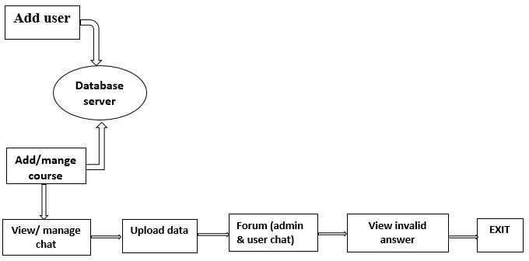

Figure 4.1: System Architecture for QSAR Fish Toxicity

There are two diﬀerent ways to normalize the size of a digit: One, we may resize the digit by leaving its proportions intact. We called this 1:1 scaling. While this gives a natural-looking digit, a tall digit will have many white pixels just because of its proportion, and these do not contribute much to the recognition process. Two, we may resize the digit arbitrarily to use the available space as fully as possible, and have the learning algorithms cope with the resulting distortions.

We called the latter approach arbitrary scaling. Downscaling always means a loss of information. If we were to downscale to a black-and-width bitmap, the loss of information would be quite huge. Therefore, downscaling is usually done to a grayscale bitmap where the gray values still retain some information of the distribution of black pixels within each downscaled pixel. We used the Mitchell filter from Image Magic for downscaling, which was default for that operation.

It has a parameter to control blurring gives natural-looking digits with sharp edges. A setting of 2.5 with arbitrary scaling gives blurred-looking digits but improves classification performance. Shows the former setting on the left, and the latter on the right.

All in all, a setting of blur=2.5 for the Mitchell filter and arbitrary scaling to 16x16 pixels were found to give the best results with several diﬀerent classifiers. In fact, for arbitrary scaling to 16x16 pixels, the test set error as a function of blur was found to be approximately quadratic with a global minimum at blur=2.5.
CHANDIGARH UNIVERSITY

Our Recognition System- It is very fast in processing, more responsive, and more useful for the university, attractive user friendly and GUI. It gives better and accurate result of the student query. Students can thus familiarize themselves with a campus quickly, start feeling at home and have much lower chances of dropping out after those first few weeks.

Available files in the dataset

So, before starting further deep in this topic, the better point should be to get familiar with the provided dataset. Following points are same in training and testing set along with the set of the images and labels files –

Pixels are arranged row-wise, ranging from 0 to 255, as from RGB color code.

Background as white (0 value from RGB) and foreground as black (255 value from RGB).

Labels of digits classified from 0 to 9.

There are four files of training and testing are:

Training set images files (train-images-idx3-ubyte) Training set labels file (train-labels-idx1-ubyte)

Test set images files (t10k-images-idx3-ubyte) Test set label files (t10k-labels-idx1-ubyte)

Back End

NumPy

  - NumPy is a library for the Python programming language, adding support for large, multi-dimensional arrays and matrices, along with a large collection of high-level mathematical functions to operate on these arrays.

SKLearn

  - Scikit-learn is a free software machine learning library for the Python programming language. It features various classification, regression and clustering algorithms including support vector machines, random forests,
CHANDIGARH UNIVERSITY

gradient boosting, k-means and DBSCAN, and is designed to interoperate with the Python numerical and scientific libraries NumPy and SciPy.

Tensorflow

- Tensorflow is a leading platform for building Python programs to work with human language data. It provides easy-to-use interfaces to over 50 corpora

and lexical resources such as WordNet, along with a suite of text processing libraries for classification, tokenization, stemming, tagging, parsing, and semantic reasoning, wrappers for industrial-strength NLP libraries, and an active discussion forum.

- Flask

Flask Tutorial provides the basic and advanced concepts of the Python Flask framework. Our Flask tutorial is designed for beginners and professionals.

Flask is a web framework that provides libraries to build lightweight web applications in python. It is developed by Armin Ronacher who leads an international group of python enthusiasts (POCCO).

Before you start proceeding with this tutorial, we are assuming that you have hands-on experience on HTML and Python.

DESIGN

Use Case Diagram:
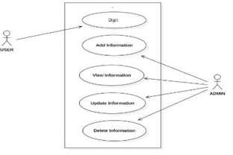

Figure 4.2:

20

CHANDIGARH UNIVERSITY

IMPLEMENTATION

- Logistic Regression

In records, the logistic model (or logit version) is used to version the opportunity of a sure elegance or event present along with pass/fail, win/lose, alive/dead or healthful/sick. This may be extended to model numerous instructions of events along with figuring out whether an picture carries a cat, dog, lion, and so forth. Each object being detected within the picture would be assigned a opportunity between 0 and 1 and the sum including to one.

Logistic regression is a statistical version that during its primary shape uses a logistic feature to model a binary structured variable, even though many greater complicated extensions exist. In regression evaluation, logistic regression (or logit regression) is estimating the parameters of a logistic version (a shape of binary regression). Mathematically, a binary logistic model has a dependent variable with two viable values, inclusive of pass/fail that is represented with the aid of a hallmark variable, wherein the 2 values are labeled "zero" and "1".

- Heteroskedasticity Corrected

We will define heteroscedasticity because the condition wherein the variance of blunders term or the residual term in a regression model varies. Possible motives of springing up Heteroscedasticity:

Often happens in those statistics units that have a large variety between the biggest and the smallest found values i.e. While there are outliers.

When version isn't always successfully unique.

If observations are mixed with one-of-a-kind measures of scale.

When incorrect transformation of records is used to perform the regression. Skewness in the distribution of a regressor, and may be some other resources.

- Weighted Least Square

It is the special case of the generalized least square and called weighted least rectangular. It seems when the off-diagonals of the correlation matrix are null but it is able to be feasible that everyone the variances of the attributes are unequal.
CHANDIGARH UNIVERSITY

DESIGN:
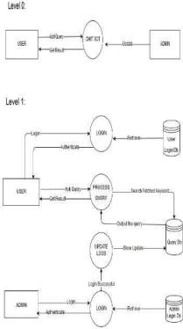

Figure4.3 : DFD
CHANDIGARH UNIVERSITY

CHAPTER 5: RESULTS AND DISCUSSION

In this section we are defining the table which includes all the machine learning algorithms which are being used by us in order to get the desired accuracy as per our assumptions for the given dataset which is QSAR Fish Toxicity^{[17]}. We are using various machine learning algorithm which are: - Logistic Regression, Heteroskedasticity Corrected, Weighted Least Square, Two Stage Least Square and Ordinary Least Square and using these mentioned algorithm we got accuracy for each algorithm there are different accuracies and for few algorithm they are same also and all these details are mentioned in the table mentioned below: -

Accuracy | Methods Used
88.2 | Logistic
 | Regression
93.6 | Heteroskedasticity
 | Corrected
85.5 | Weighted Least
 | Square
85.5 | Two Stage Least
 | Square
85.5 | Ordinary Least
 | Square

In this section of the paper we are defining and analyzing the various machine learning algorithms which are used by us to get the desired accuracy for the given dataset which is QSAR Fish Toxicity. To get to the result we have implemented various machine learning algorithms in order to get the desired accuracy which are: - Logistic Regression, Heteroskedasticity Corrected, Weighted Least Square, Two Stage Least Square, Ordinary Least Square. After analyzing all the algorithms we got that the Heteroskedasticity Corrected is the algorithm which is capable of providing the accuracy as per our assumptions. The accuracy which we got from the Heteroskedasticity Corrected algorithm is 93.6%.

CHANDIGARH UNIVERSITY

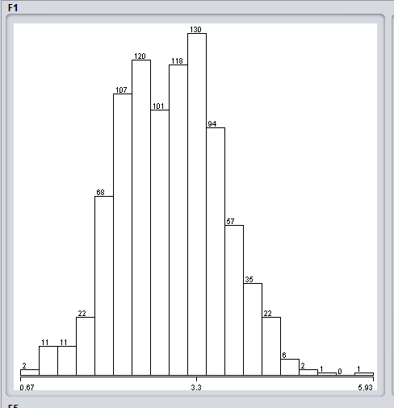

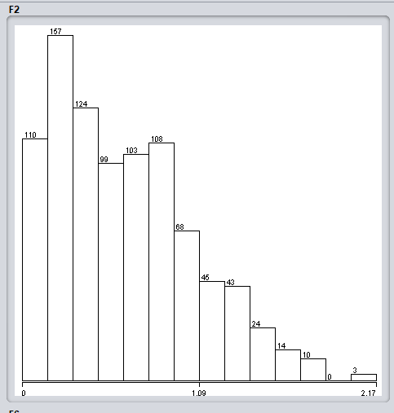

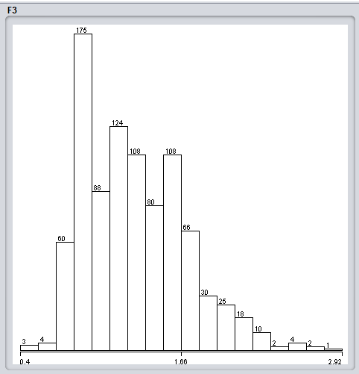

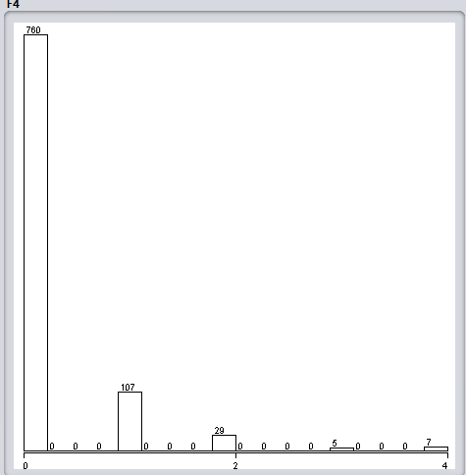

CHANDIGARH UNIVERSITY
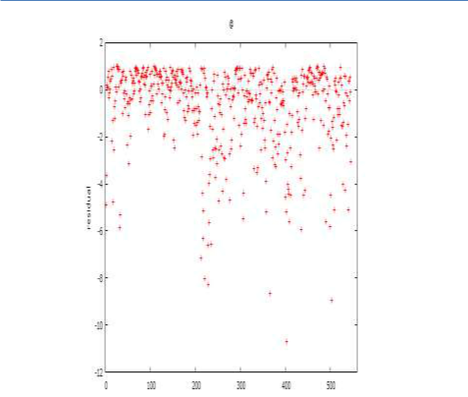

Figure 3 Residual Plot

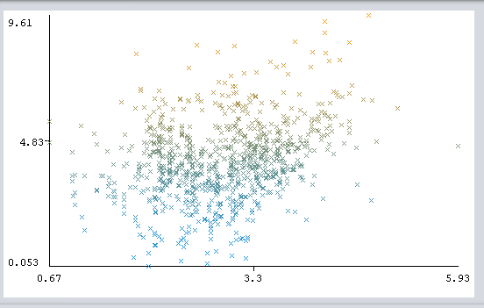

Figure 3 is the residual plot between the total quantities and the residuals also as this graph defines the quantities which are residues of the given dataset used by us.

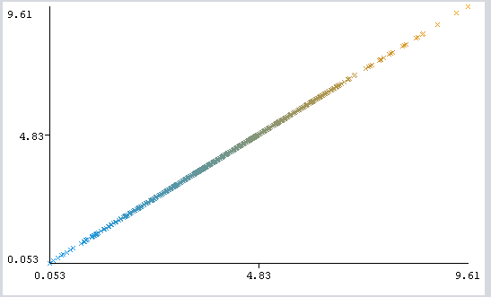

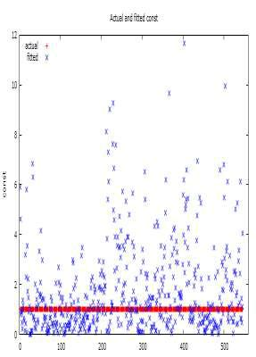

Figure 4 Actual v/s Fitted

Figure 4 defines the values visualized between the actual and the fitted variables of the different attributes^{[13]}. The red points are the actual points and the blue points are the fitted values which are being used to perform the operations on the given dataset.

Comparison with Existing Project

Comparison with Related Work Previous works have utilized different datasets for knowledge acquisition for different applications. Shrestha and McKeown [2004] use an email corpus. Zhou and Hovy [2005] use Internet.

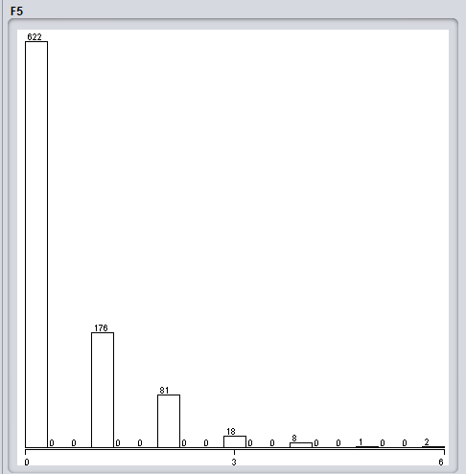
CHANDIGARH UNIVERSITY

There are several reasons for the 25.6% inaccuracy: The main reason for the system inaccuracy is because the number of training sample for a digit was not enough. From the results of other documentation of the same type of project [7], we find that when they use more training sample the more accurate they can get. But because the scope and time frame of this project is small therefore we limited the amount samples to test and compare. Another limiting factor is the basic setup of this project, we are simply using the most basic algorithms for feature extraction and classification therefore it is hard to have good results compared to a more elaborate designed system. A factor of the system that changes the accuracy are the number of eigenvector values we consider, increases the number of significant values we increase the accuracy in a linear fashion. This make sense because the values from the eigenvectors represents the feature of the digit, the more we use to compare to our test case the more information we can get from the distance metrics.

The actual digits are in the following order 2, 1, 7. Given their similar features visually, it would be difficult to have a mathematical expression for them that is perfectly unique to each digit they belong to. The increase of samples in a training algorithm will definitely help in the accuracy of the results but in some cases where the digit looks like something else it would be hard to find a good mathematical expression for them to be compared by a computer without errors.

User‐Independent Online Handwritten Digit Recognition [6], this system uses a

local based recognition system. It considers the stroke of the digit and characterizes them for the classifier, the different strokes are assigned a number therefore each digit can be encoded by the starting stroke to ending stroke.

With this feature code, it can be used in simple classifiers. This implementation is

good because it doesn’t require a training system but the main disadvantage is the

problem of classifying the strokes. There are problems with clockwise and

counter‐clockwise digits. Our solutions is simpler implementation because it uses

a global approach instead of local approach which still gives accurate recognitions without the amount of work required for localized approach.

These are all examples of the digit 9. For the last one it is actually hard for a person to figure out it’s a 9 instead of a 4.
CHANDIGARH UNIVERSITY

One of the chief advantages of the system is that it doesn’t require any learning for

the system as compared to neural network recognition system. Their

implementation consists of the same steps as our implementations, pre‐process, feature‐extraction and classification (multi‐features). The main difference is their feature‐ extraction and multi‐features classification. The features they extract are

the end points of the digits, and depending on the distances of two endpoints they could be connected or deleted. An example of this system is to consider the circle of nine that is unclosed from the image, depending on how far the two endpoints are they could be connected to create a closed loop for better classification. Using the number of endpoints they can classify into smaller sets of digits to compare with eventually ending into a result. The problem with this implementation is the number of algorithms we need to implement; therefore we did not choose this solution.
CHANDIGARH UNIVERSITY

CHAPTER 6: CONCLUSION AND FUTURE SCOPE

In the above mentioned paper we have examined various machine learning algorithm to predict the accuracy for the given dataset which is QSAR Fish Toxicity and for that we examined that Heteroskedasticity Corrected is the better accuracy which is capable of providing the accuracy as per our assumptions and also few are there which are good enough but not better than Heteroskedasticity Corrected algorithm that is Logistic Regression. Although we got the accuracy of 93.6% but there are chances of increasing the accuracy as well as we can take the accuracy better than the mentioned above.

This dataset become used to develop quantitative regression QSAR fashions to expect acute fish toxicity towards the fish Pimephales promelas (fathead minnow) on a hard and fast of 908 chemicals. To predict acute fish toxicity closer to Daphnia Magna. LC50 records, which is the concentration that reasons death in 50% of test D. Magna over a test period of 48 hours, became used as version response. The model comprised eight molecular descriptors: TPSA(Tot) (Molecular properties), SAacc (Molecular houses), H-050 (Atom-targeted fragments), MLOGP (Molecular homes), RDCHI (Connectivity indices), GATS1p (2D autocorrelations), nN (Constitutional indices), C-040 (Atom-concentrated fragments). Details may be determined in the quoted reference: M. Cassotti, D. Ballabio, V. Consonni, A. Mauri, I. V. Tetko, R. Todeschini (2014).

The dataset which we're the usage of is taken from the UCI Repository as in advance the dataset changed into no longer easy enough to perform the operation for that we were required to easy the dataset as it helped in accurately predicting the output.

In this section we are discussing about the proposed problem. Our main concern/plan of action for doing this research was to get a accuracy using various machine learning algorithm better than the results which are available for us to work upon. As it is very important to get a accuracy better because the dataset is about the fish life toxicity prediction which is somehow related to human beings as pare the law of mother nature if one element in the food chain get disturbed then the whole system is effected with this change/effect.
CHANDIGARH UNIVERSITY

It is very important to search for a machine learning algorithm which is capable of predicting the accuracy accurately so that we can save the lives of the fish animals from the toxic elements and thus how we can save us from damage as well as save the other animals for doing such an operation it is very important to get a dataset which includes all the details related to our requirement and the dataset was available in the UCI Repository The dataset which we got become absolutely uncleaned there were many issues inside the dataset few of them are: - dataset on which we had been running changed into in a unmarried mobile i.E. More than one attributes have been within the unmarried cellular, the opposite problem turned into of the Null values and the blanks which we need to care of earlier than running/intending similarly with this dataset. As earlier than running on any of the dataset first of all we have to easy the dataset well as the dataset we were given very easily from the UCI Repository however to clean that dataset was a big assignment in front people as after fixing this hassle we are able to flow ahead with the other steps and get a higher accuracy. After cleaning of the dataset is performed the other problem become to discover an algorithm that may without difficulty expect the sample inside the dataset and provide us the specified output. Although earlier the paintings is achieved on the given dataset however we've selected this dataset to get the better anticipated accuracy than the accuracy that's in the earlier studies papers. Our most important problem changed into to get a device mastering algorithm that's capable of supplying the results as in line with our assumptions for that it is important to perform operations on numerous device learning algorithms and if fails to find the set of rules then we are able to circulate ahead to generate our very own algorithm to be able to get the effects as according to our as in line with our requirement and assumption.
CHANDIGARH UNIVERSITY

REFERENCES

Shawar, Abu, Eric Atwell, and Andrew Roberts. "Faqchat as in information retrieval system." Human Language Technologies as a Challenge for Computer Science and Linguistics: Proceedings of the 2nd Language and Technology Conference. Poznań: Wydawnictwo Poznańskie: with co-operation of Fundacja Uniwersytetu im. A. Mickiewicza, 2005.

Rahman, A. M., Abdullah Al Mamun, and Alma Islam. "Programming challenges of chatbot: Current and future prospective." 2017 IEEE Region 10 Humanitarian Technology Conference (R10-HTC). IEEE, 2017.

Abdul-Kader, Sameera A., and J. C. Woods. "Survey on chatbot design techniques in speech conversation systems." International Journal of Advanced Computer Science and Applications 6.7 (2015).

Shawar, Bayan Abu, and Eric Atwell. "A corpus-based approach to generalising a chatbot system." Procesamiento del lenguaje natural 31 (2003).

Xuetao, Mao, François Bouchet, and Jean-Paul Sansonnet. "Impact of agent’s answers variability on its believability and human-likeness and consequent chatbot improvements." Proc. of AISB. 2009.

Klüwer, Tina. "From chatbots to dialog systems." Conversational agents and natural language interaction: Techniques and Effective Practices. IGI Global, 2011. 1-22.

Lalwani, Tarun, et al. "Implementation of a Chatbot System using AI and NLP." International Journal of Innovative Research in Computer Science & Technology (IJIRCST) (2018).

Jia, Jiyou. "The study of the application of a keywords-based chatbot system on the teaching of foreign languages." arXiv preprint cs/0310018 (2003).

Quarteroni, Silvia, and Suresh Manandhar. "A chatbot-based interactive question answering system." Decalog 2007 83 (2007).

Xiaojiang, Duan. "Chatbot system and method with contextual input and output messages."

U.S. Patent Application No. 13/661,040.

Shawar, Abu, and E. S. Atwell. "A chatbot system as a tool to animate a corpus." ICAME Journal: International Computer Archive of Modern and Medieval English Journal 29 (2005): 5-24.

AbuShawar, Bayan, and Eric Atwell. "ALICE chatbot: Trials and outputs." Computación y

Sistemas 19.4 (2015): 625-632.

Jia, Jiyou. "CSIEC: A computer assisted English learning chatbot based on textual knowledge

and reasoning." Knowledge-Based Systems 22.4 (2009): 249-255.

Duan, Xiaojiang. "Chatbot system and method with interactive chat log." U.S. Patent Application No. 13/661,045.

